HOW TO SHOOP ANIME SKIN
First check iqdb, saucenao, and Google _mage search for the best image version. Open the image in Photoshop. 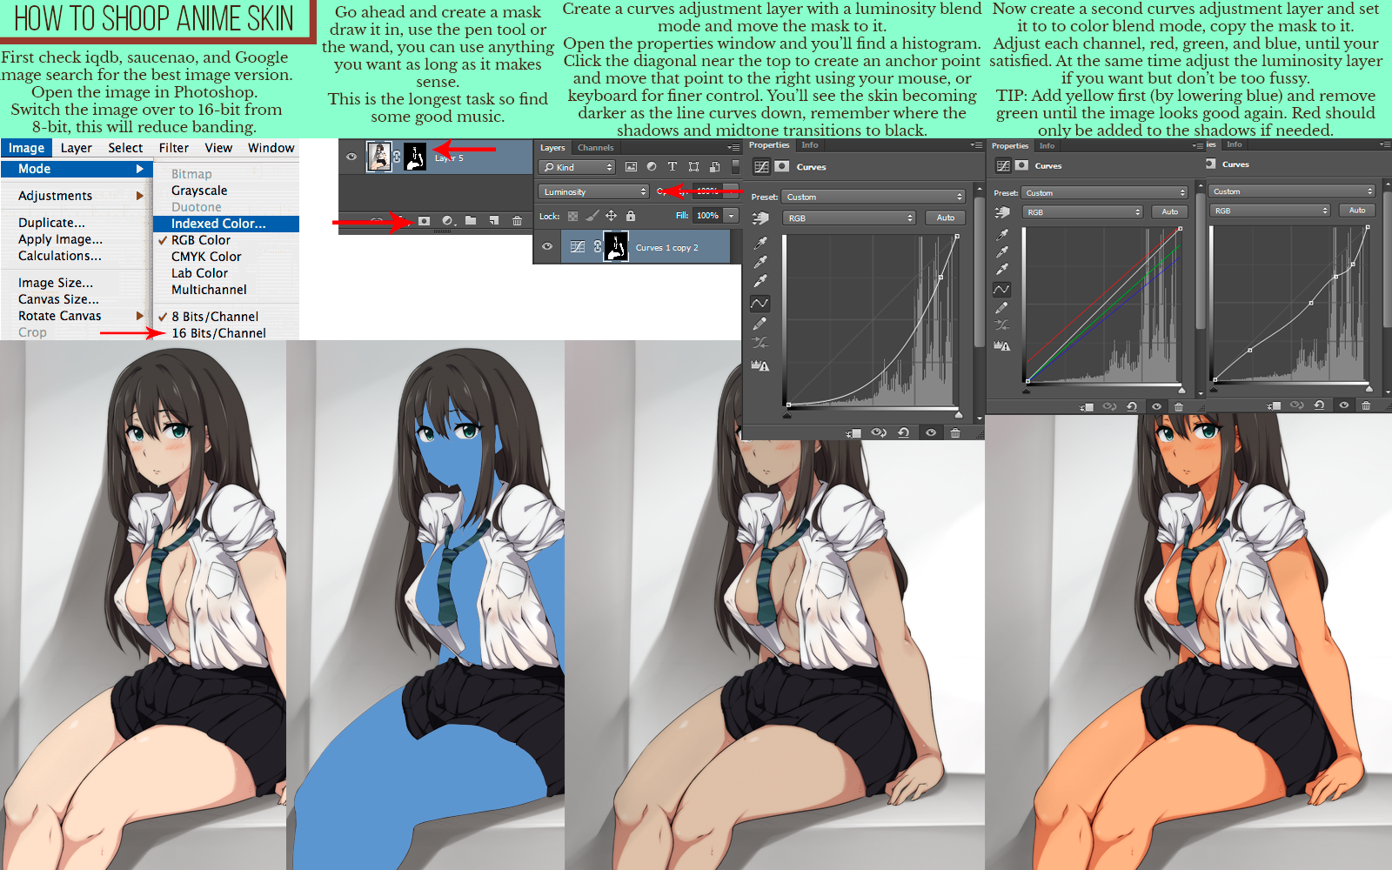Switch the image over to 16-bit from 8-bit, this will reduce banding. Image Mode
Layer Select Filter View Window
Adjustments
Duplicate... Apply Image... Calculations... Image Size... Canvas Size... Rotate Canvas Crop
Bitmap Grayscale Duotone
Indexed Color...
✓ RGB Color
CMYK Color Lab Color Multichannel
✓ 8 Bits/Channel
16 Bits/Channel
Go ahead and create a mask draw it in, use the pen tool or the wand, you can use anything you want as long as it makes
sense.
This is the longest task so find some good music.
O
Layer 5
•
O
目
Create a curves adjustment layer with a luminosity blend Now create a second curves adjustment layer and set mode and move the mask to it.
Open the properties window and you'll find a histogram. Click the diagonal near the top to create an anchor point and move that point to the right using your mouse, or keyboard for finer control. You'll see the skin becoming darker as the line curves down, remember where the shadows and midtone transitions to black. ▾ Properties Info
Layers Channels
Curves
Kind
Luminosity
Preset: Custom
Lock:關
→ A
Fill: 100%
RGB
Curves 1 copy 2
O
it to to color blend mode, copy the mask to it. Adjust each channel, red, green, and blue, until your satisfied. At the same time adjust the luminosity layer if you want but don't be too fussy. TIP: Add yellow first (by lowering blue) and remove green until the image looks good again. Red should only be added to the shadows if needed.
Properties Info
Curves
ies Info
⚫Curves
Custom
Preset: Custom
RGB
Auto
RGB
Auto
A
A

